**Housing in South Korea**

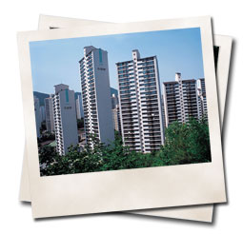Expect to live in an apartment, a fairly small apartment. Since Korea is one of the most densely populated countries on earth only the extremely wealthy or those in rural areas can afford to live in houses.

Korean apartments tend to be around 30% smaller than apartments in the USA or Canada. Because Korea was rebuilt rapidly after the Korean war and the government wished to alleviate the chronic shortage of housing, rows of identical apartment buildings march across the country side. It's actually quite surreal how each city has exactly the same apartments... everywhere... Newer developments and housing areas are developed with green space in mind and offer a lot more in terms of local amenities as a result of urban planning efforts. What's most remarkable is how quickly Korea has changed. If you left 5 years ago, you would hardly recognize some areas that used to be your favorite haunts.

**What to Expect - What NOT to Expect**

Don’t expect a clothes dryer- Koreans typically wash their clothes in a washing machine and hang them to dry on drying racks or clothes lines on their balcony. 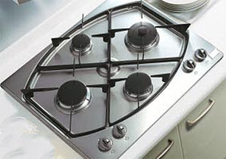

Don’t expect your apartment in [Korea](http://www.footprintsrecruiting.com/teaching-jobs-in-asia/teaching-jobs-in-korea) to have an oven. Virtually all Korean cooking is done on a range top - so your apartment will most likely just have a gas range for cooking. This style of cooking is in some ways due to the population density of the country - far less fuel is used to cook small pieces of food over a flame than is used in roasting or baking - besides, have you ever tried to eat a rib roast with chopsticks?

Cooking can be really difficult for some not used to turning the oven on to warm up pizza and the kitchen is quite small so there is limited room to do fancy cooking. As a note, some people buy a movable extra counter top. As mentioned, the stoves are gas so it can be exciting. I have burned myself and the food and I’m always worried about the leaving the gas on and blowing myself up but you get used to it fairly quickly.

Don't expect to have a bathtub. Again, this is a space issue.

You will notice other idiosyncrasies about your apartment that are different than the western style apartments. When you walk in the front door you will notice a small alcove, and perhaps an oddly shaped bookshelf by the door. Koreans always take off their shoes when entering a house, thus you are meant to take off your shoes in this alcove and put them on a shelf for the time that you are in the apartment. **Never wear your shoes into a Korean household.**

Korean apartments are typically heated differently than western apartments. Korean apartments use a heating system called "ondol", which is essentially hot water pipes running underneath the floor. This is one of the best things about your apartment. There is nothing better than in winter watching a movie, with the ondol on and you're lying on the floor. Since heat rises, (I did learn something in high school physics…) this is an energy efficient heating system. I would think more homes in cold countries like Canada would also use this system... appears only to be the case in the really wealthy homes.

In Korea, virtually all apartments are heated using a hot water system, the same system that heats the floor also heats your hot water. Many apartments will have a complicated dial that switches the hot water between the floor and the shower. If you adjust the dial just right, you can have a freezing cold apartment and shower at the same time. Don’t try to figure this out on your own - ask a Korean for help.

You may have a roommate or a studio apartment depending on the school, but you will definitely have your own bedroom unless you choose not to. Many Korean apartment buildings also have security guards whose main functions are to sleep, watch television and to tell your boss what time you came home, and with who. Once you find out where your apartment is, you should have a Korean friend or colleague or head teacher write down your address IN KOREAN and then you can carry this around with you in case you ever get lost.

Apartments were numbered by the order in which they were built, not in the order in which they are on a street... urban planning has changed this but in older communities or areas this was/is not the case thus building 817 may be next to building 825, which is next to 812, and so on.

To further confuse things cities are divided into large administrative districts called "ku" and smaller districts called "dong". Buildings within a dong are numbered but can be anywhere within the area - identify landmarks around your building and if you get hopelessly lost ask a Korean, or show him or her the piece of paper with your address on it. Be careful asking Koreans for directions, however, they will often give you completely misleading directions rather than admit they don’t have a clue where you want to go.

All apartments will also come with a laundry room/balcony. There is a sliding glass door that opens to what almost looks like a closed in balcony. The floors are tile, there is a small closet and a large window. There is a laundry machine and a drying rack. The laundry machine is in Korean so ask for help the first time you use it. Some machines will sing a song when it is finished it’s cycle! There isn’t a dryer but the clothes dry fairly quickly. I usually do laundry before school and it’s dry when I get home.

Apartments aren't fancy but they are cozy and it's yours to call home for a year. The heated floors are great and there is usually lots of character.

**Bathrooms in Korea**

The most commonly asked question about housing in Korea is usually about the type of toilet a teacher is going to have: you will have an western style toilet. 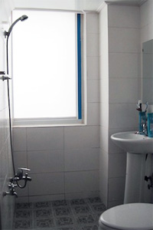

Bathrooms are configured differently in Korea - don’t expect a bathtub, and the shower may consist of a shower head sticking out of the wall. Koreans don’t use shower curtains. This may seem odd at first, but the bathrooms are tiled and the floor is at a slight incline with a drain in it.

Thus you can splash as much water as you like all over the bathroom without worrying about getting water on the floor. This also makes cleaning the bathroom a cinch - throw all your shampoo bottles in the living room, hose down your bathroom with the shower head and presto, a clean bathroom. A word to the wise, also remove the toilet paper before hosing down your bathroom.

**Note:** The only places where you will experience traditional ‘squat’ style toilets - basically a porcelain covered hole in the floor - is in the countryside and some public restrooms. You will not have a squat toilet in your apartment - you will have a normal, western style flush toilet. If faced with using a squat toilet, there are a few tricks to remember. Squat facing the rounded porcelain hood of the toilet as if you were going to play leap-frog, you wouldn’t want to suffer the embarrassment of someone discovering you using the toilet backwards! Make sure your pants and undergarments are out of the way, or you may have a distinctly uncomfortable rest of the day, and try not to splash.

**Furnished Housing For Teachers in Korea**

One of the standard questions we get from teachers heading to South Korea is, what is my apartment going to be like?  Let's work from the basics so that your expectations aren't too lofty.

First, forget about a bath.  I have only seen a handful of baths in all of Korea and we are talking over a decade now of experience... tracking into almost 2 decades.  The one plus is that if you can get past being naked in front of a bunch of people who are of the same gender as you, the Mog-yotang.

Second, forget about an oven.  You might have a toaster oven and if you don't... you can buy one.

Virtually all apartments in Korea come with the following: 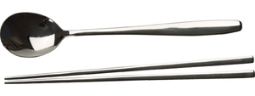

* western style bed
* table and chairs
* bureau/wardrobe
* TV and likely a VCR or DVD
* fridge
* washing machine
* western style toilet
* stove
* basic cooking supplies
* basic forks, knives, spoons and chopsticks
* basic cleaning supplies

If you don't have these basics, ask your Head Teacher or the manager.